**Procedures for Individual Frequency Band Calculation (using the Emotiv Headsets)**

1. Determine bad channels for each participant
   1. Calculate overall average and standard deviation of log power between 0.5-40 Hz across all 14 channels
      1. For each channel, calculate average log power between 0.5-40 Hz and compare this to the overall average
      2. 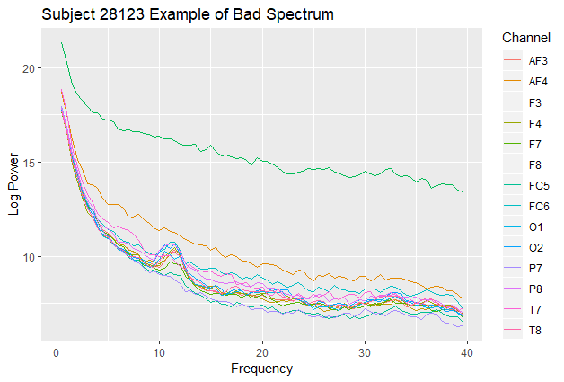If the channel average is greater than +/- 2.5 SD from the overall average, then the channel is excluded (see below for an example in which F8 is excluded)
   2. For each channel, determine if there is an alpha peak
      1. An alpha peak is defined as an increase of at least 0.2 log power between 7.5-15 Hz
      2. 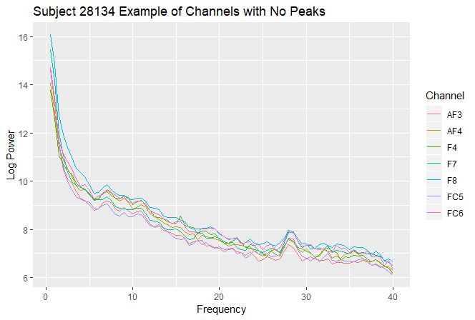If the channel does not have an alpha peak, then the channel is excluded (see below for an example)
2. Determine bad participants
   1. Determine the number of excluded channels
      1. If 8 or more channels were excluded, then the participant is excluded
3. Determine IAF for each good participant
   1. Calculate overall average log power between 0.5-40 Hz across all good channels
   2. Determine the IAF within the overall average log power spectrum
      1. 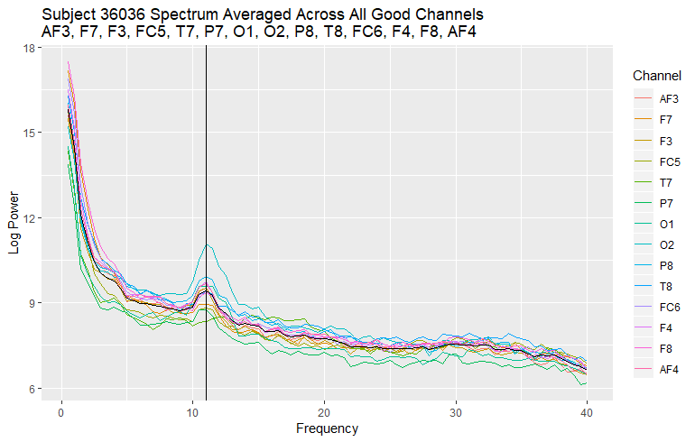IAF is defined as the frequency bin between 7.5-15 Hz in which the alpha peak occurs (see below for an example in which the black horizontal line is the average spectrum and the black vertical line is the identified IAF)
4. Define the individualized frequency bands
   1. Delta = 0.5 to IAF – 6.5
   2. Theta = IAF – 6 to IAF – 2.5
   3. Alpha = IAF – 2 to IAF + 1.5
   4. Low beta = IAF + 2 to IAF + 9.5
   5. High beta = IAF + 10 to IAF + 19.5
   6. Gamma = IAF + 20 to 40

**Descriptives for 91 monolingual participants**

1. Determine bad channels for each participant = 197/1190 (16.6%) were excluded
   1. Bad spectrum = 34/1190 (2.9%) channels were excluded for this reason
   2. No Peak = 163/1190 (13.7%) channels were excluded for this reason
2. Determine bad participants = 6/91 (6.6%) participants were excluded
3. Determine IAF for each participant
   1. Here is a histogram representing the identified IAFs across the 85 good participants
4. Define individualized frequency bands
   1. Here are histograms representing the range of the lower and upper bounds for theta, alpha, low beta, and high beta (delta and gamma are also calculated but not represented below)
   2. For reference our old static frequency bands were defined as theta (4-7.5 Hz), alpha (8-12.5 Hz), low beta (13-15 Hz), mid beta (15-18 Hz), and high beta (18-30 Hz)